Complete CI/CD Pipeline Setup Guide for FitFuel Project

# Step 1: Project Initialization

* 1. Create a new GitHub repository named `Fitfuel`.

1. <https://github.com/jaya9850/Fitfuel> (link to access the repo)
2. 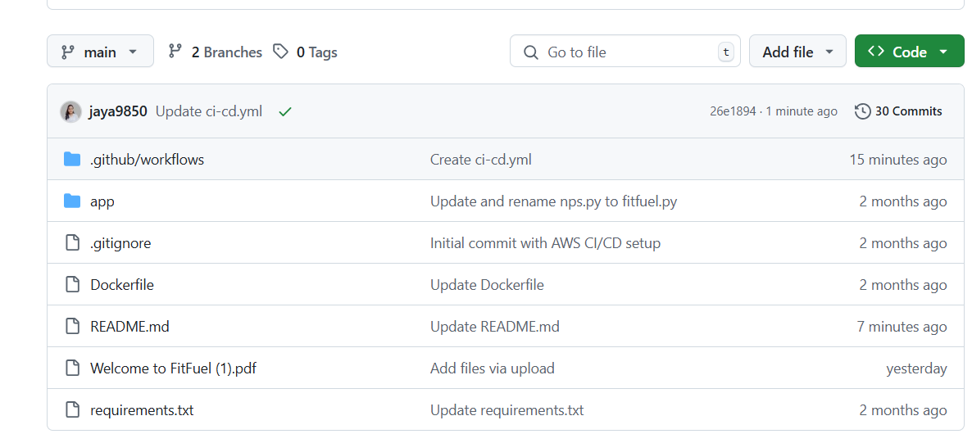

Step 2: Dockerfile Setup

Create a `Dockerfile` in the root of the repository:

# Use official Python image  
FROM python:3.9-slim  
  
# Set working directory  
WORKDIR /app  
  
# Copy requirements and install dependencies  
COPY app/requirements.txt .  
RUN pip install --no-cache-dir -r requirements.txt  
  
# Copy app source code  
COPY app/ .  
  
# Command to run the applicationCMD ["python", "main.py"]

Docker stepup on ec2

sudo apt update

sudo apt install -y docker.io

sudo systemctl start docker

sudo systemctl enable docker

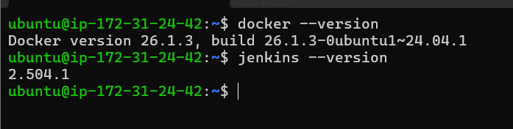

Image creation on docker on my system for testing

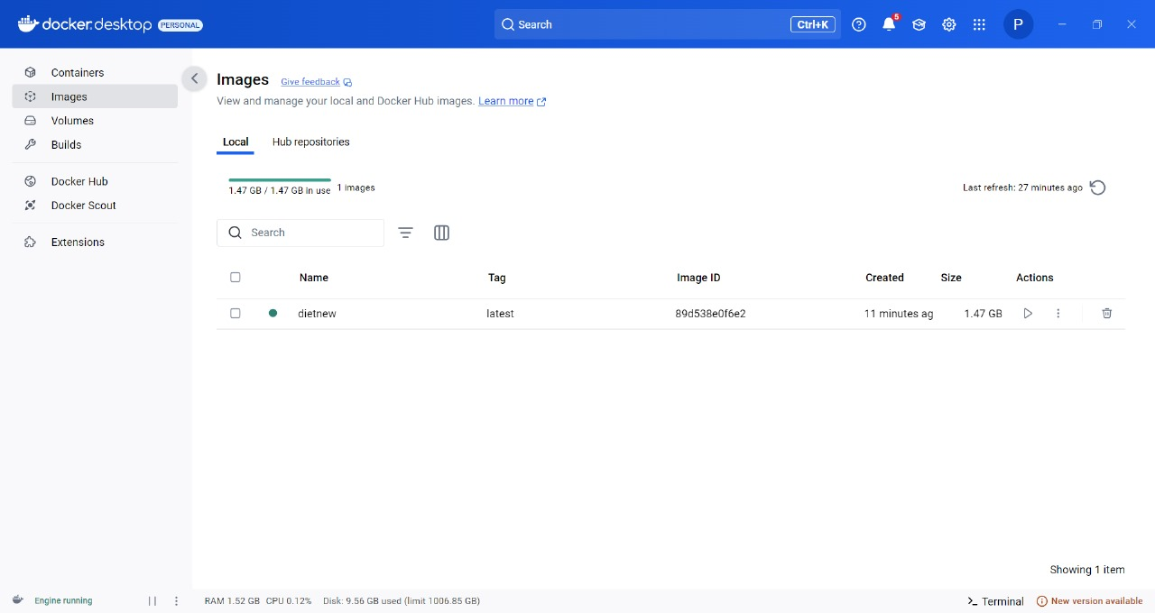

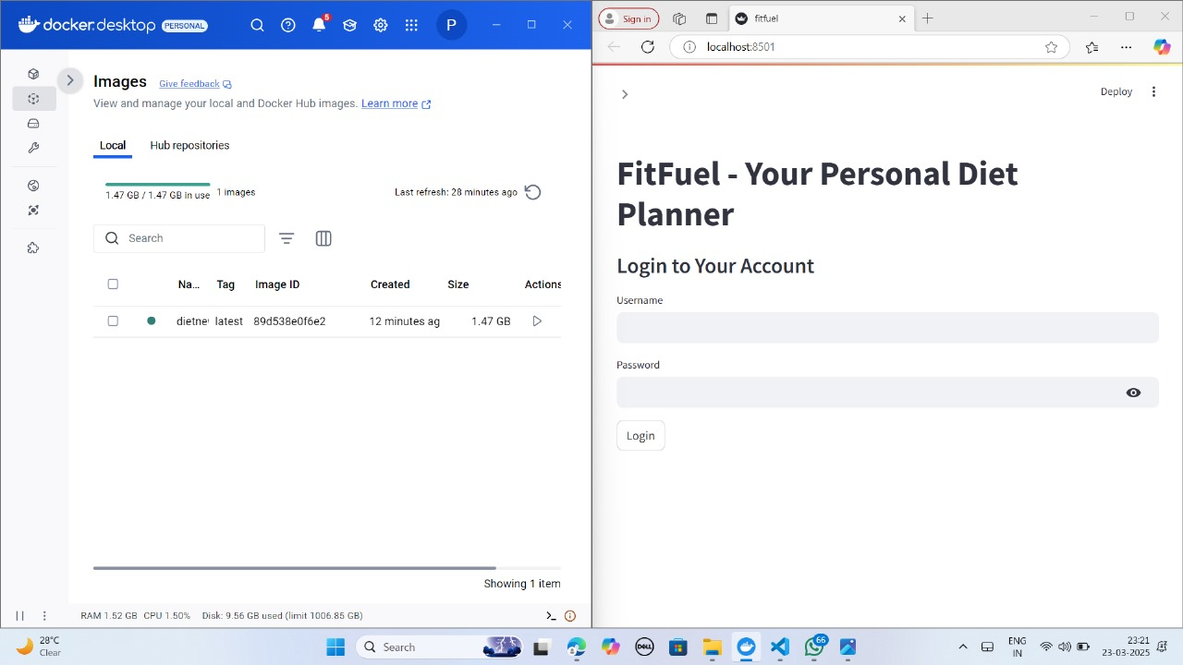

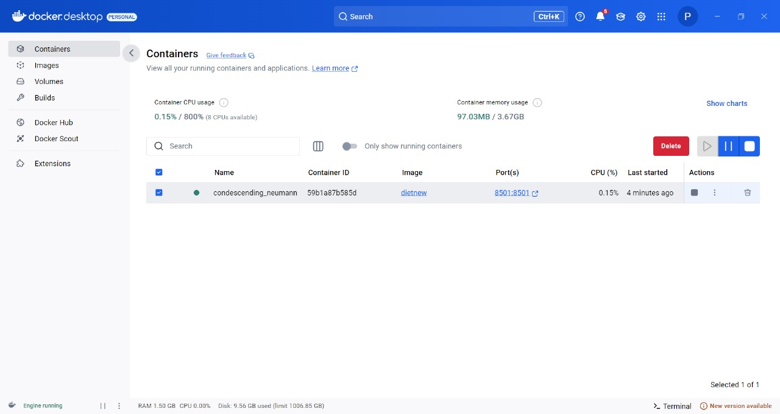

# Step 3: Jenkins Setup

3.1. Install Jenkins on an Ubuntu machine (e.g., EC2 instance):

sudo apt update  
sudo apt install openjdk-11-jdk -y  
wget -q -O - https://pkg.jenkins.io/debian-stable/jenkins.io.key | sudo apt-key add -  
sudo sh -c 'echo deb https://pkg.jenkins.io/debian-stable binary/ > /etc/apt/sources.list.d/jenkins.list'  
sudo apt update  
sudo apt install jenkins -y  
sudo systemctl start jenkins  
sudo systemctl enable Jenkins

run all this commands on ec2 instance for the Jenkins setup

**for password run this commands**

**sudo cat /var/lib/jenkins/secrets/initialAdminPassword**

**sudo find / -name "initialAdminPassword"**

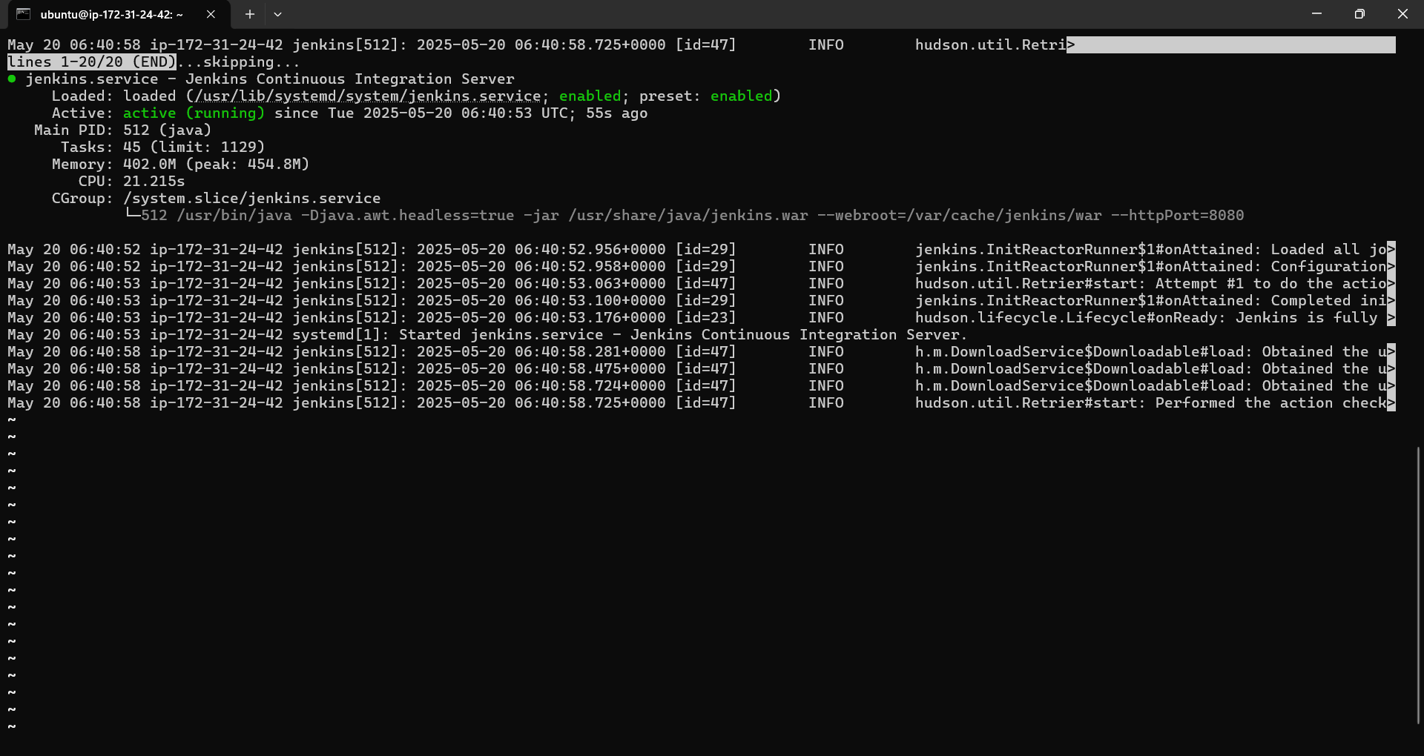

After singin give user name and password this interface will be there

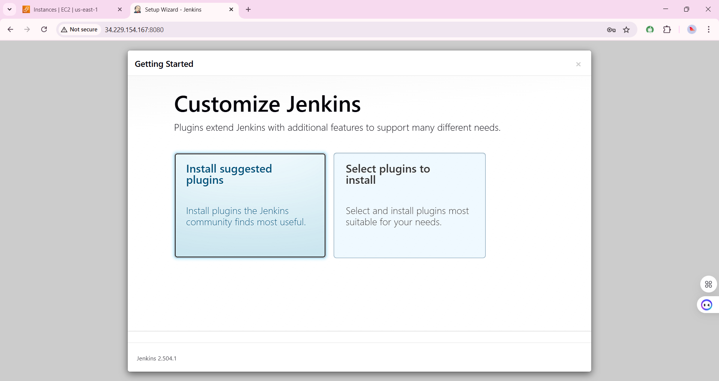

3.2. In Jenkins UI:

• Go to 'Manage Jenkins' > 'Configure System' > 'GitHub' > Add credentials.  
• Create a new Freestyle Project.  
• Under Source Code Management > Git: Add https://github.com/jaya9850/Fitfuel.git  
• Under Build Triggers: Enable 'GitHub hook trigger for GITScm polling'.  
• Under Build Steps > Execute Shell:

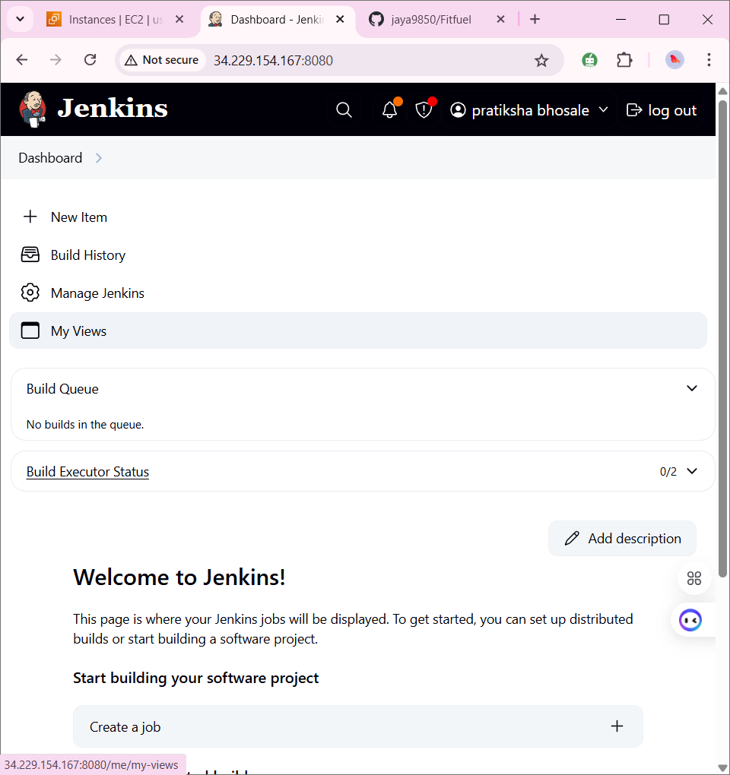

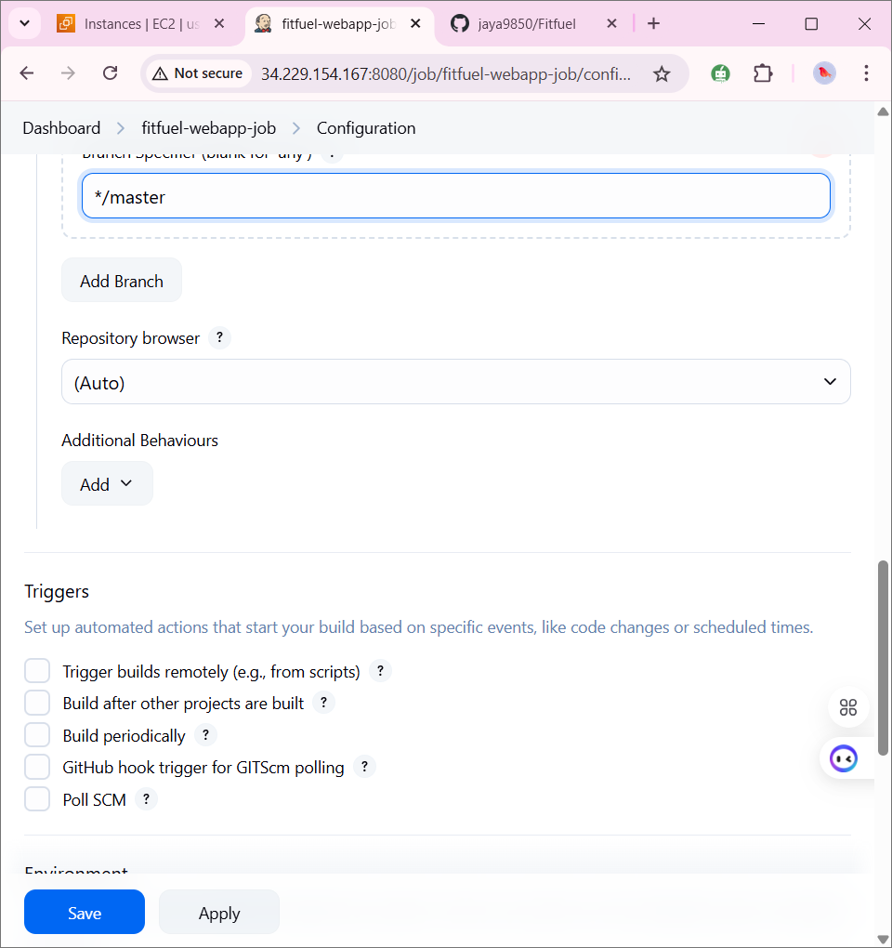

echo "Building Docker Image"  
docker build -t fitfuel-app .

3.3. Add a webhook to your GitHub repository:

• Navigate to GitHub > Settings > Webhooks > Add webhook  
• Payload URL: http://<your-jenkins-ip>:8080/github-webhook/  
• Content type: application/json  
• Select: 'Just the push event'  
• Click Save

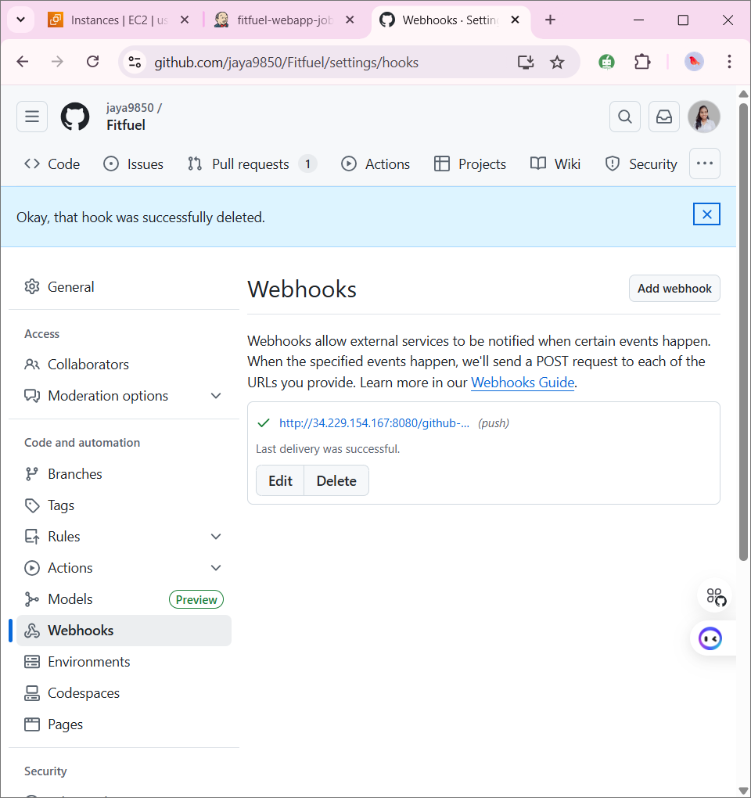

# Step 4: GitHub Actions Workflow Setup

Create a GitHub Actions workflow file at `.github/workflows/ci-cd.yml`:

name: Docker CI/CD  
  
on:  
 push:  
 branches:  
 - main  
  
jobs:  
 build:  
 runs-on: ubuntu-latest  
  
 steps:  
 - name: Checkout code  
 uses: actions/checkout@v3  
  
 - name: Set up Docker Buildx  
 uses: docker/setup-buildx-action@v3  
  
 - name: Login to DockerHub  
 uses: docker/login-action@v3  
 with:  
 username: ${{ secrets.DOCKER_USERNAME }}  
 password: ${{ secrets.DOCKER_PASSWORD }}  
  
 - name: Build and push Docker image  
 uses: docker/build-push-action@v5  
 with:  
 context: .  
 push: true  
 tags: ${{ secrets.DOCKER_USERNAME }}/fitfuel-app:latest

• Make sure to add DockerHub credentials as GitHub secrets:

GitHub > Repository > Settings > Secrets and variables > Actions:  
• DOCKER_USERNAME  
• DOCKER_PASSWORD

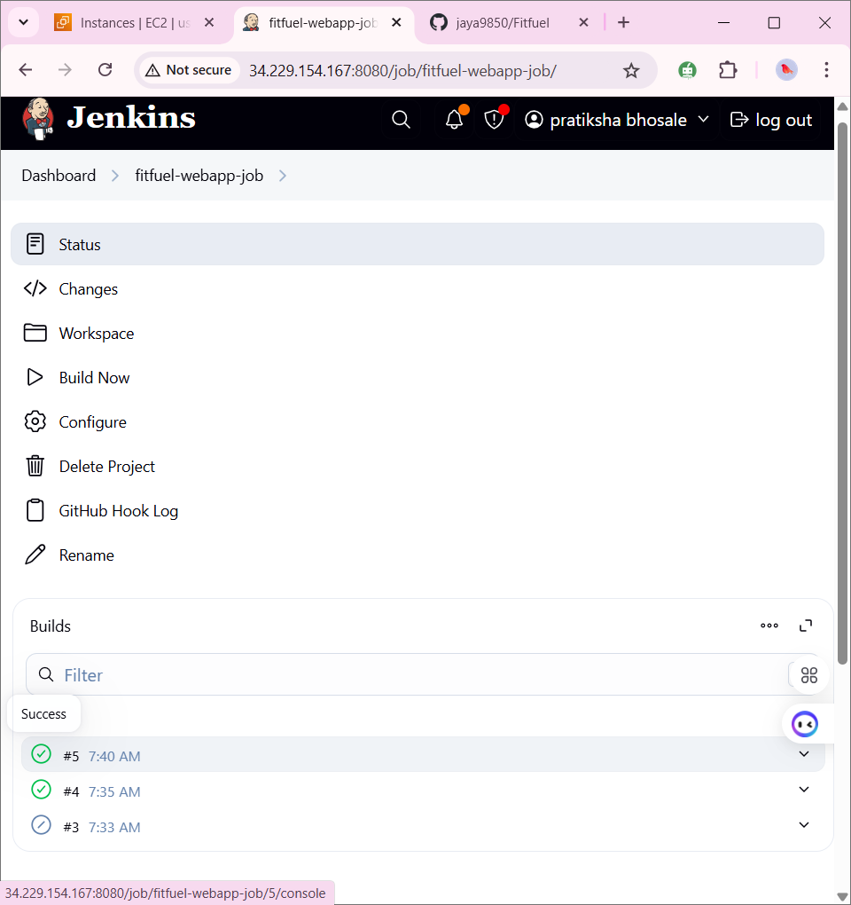

If you perform any action on your repo it will trigger the action and changes are refelects here